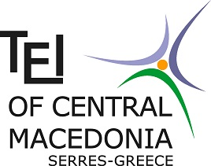 | TECHNOLOGICAL EDUCATION INSTITUTE  OF CENTRAL MACEDONIA  INTERNATIONAL RELATIONS OFFICE  Terma Magnesias str. , 621 24 Serres , GREECE  tel: + 30 23210 49 115 , Fax: +30 23210 46 556  e-mail : eu@teiser.gr  www.teiser.gr

Letter of Confirmation

It is hereby certified that

was an ERASMUS+ student at our institution

between the following dates

 | / |  | / |  | to |  | / |  | /
day |  | month |  | year |  | day |  | month |  | year

in the department(s) of

DATE |  | Stamp and Signature
Name of the Signatory:
Function:

